«Дифференциальные уравнения»
Цель: Решая предоставленные задания, изучить методы решения дифференциальных уравнений
Задачи:
Разработать программу, решающую дифференциальные уравнения
Решить предоставленные задачи
Код программы:
import math;

def func(a,b,y,n,func,br):
y0=y
x=a;
h=(b-a)/n
print(x, '|', y)
while x<b-h:
y=y+h*(eval(func))
x+=h
print(x, '|', y)
if (eval(br)):
break

Входные данные:
- 0,100,83,1000,'-0.0373*(y-22)','y<=56
- 0,10000,200,1000,'-0.00044*y','y<=y0/2'
- 0,150,12,150,'(-(b*y*0.0001))','y<0'
- 0,2,0,1000,'((300-y*150)/30)','y>1.98'

Выходные данные:
1)
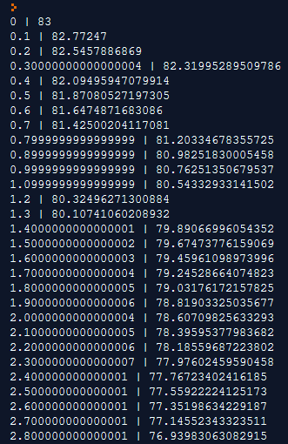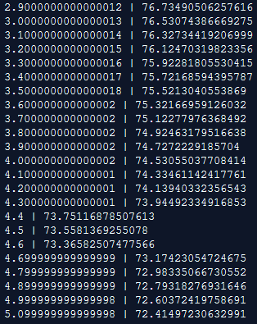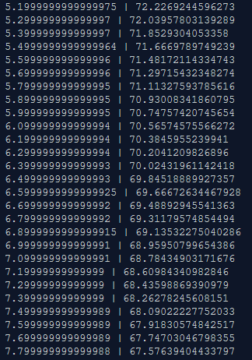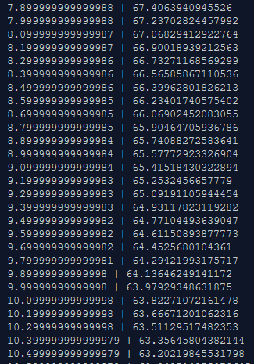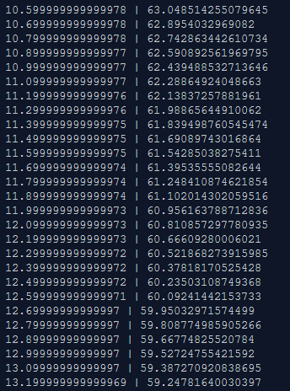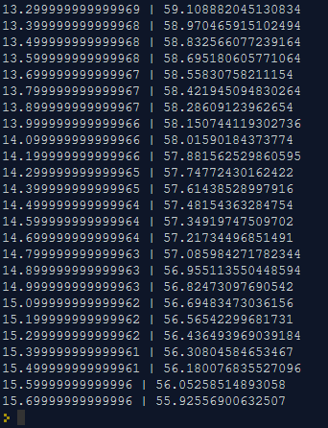

2)
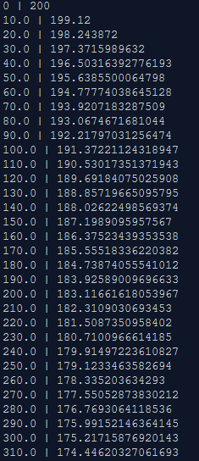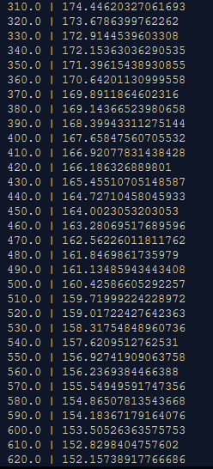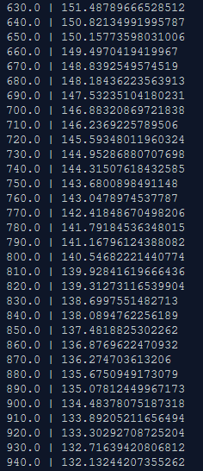
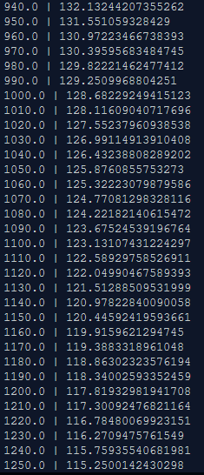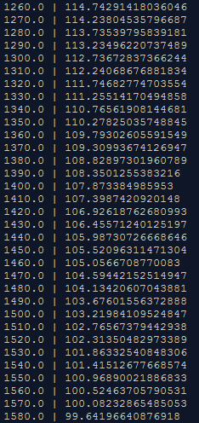

3)
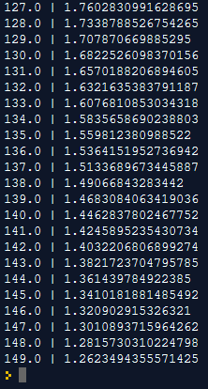
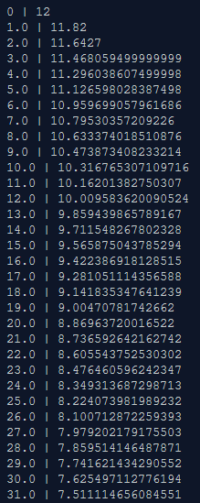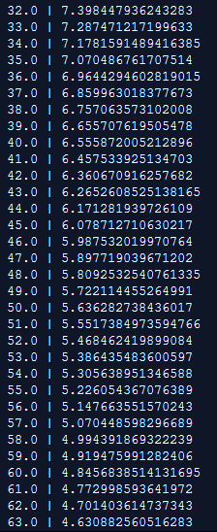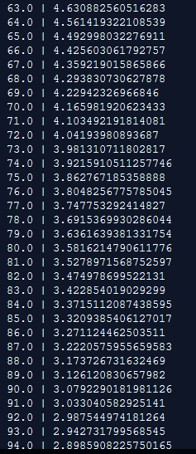
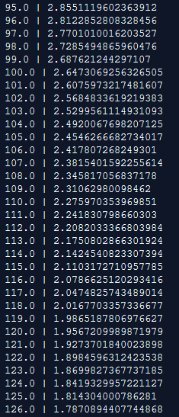

4)
Вставляю таблицу результатов из-за невозможности заскриншотить настолько большой объем данных.
0 | 0
0.002 | 0.02
0.004 | 0.0398
0.006 | 0.059401999999999996
0.008 | 0.07880798
0.01 | 0.09801990020000001
0.012 | 0.11703970119800002
0.014 | 0.13586930418602
0.016 | 0.15451061114415982
0.018000000000000002 | 0.1729655050327182
0.020000000000000004 | 0.19123584998239102
0.022000000000000006 | 0.2093234914825671
0.024000000000000007 | 0.22723025656774143
0.02600000000000001 | 0.24495795400206402
0.02800000000000001 | 0.2625083744620434
0.030000000000000013 | 0.27988329071742296
0.032000000000000015 | 0.2970844578102487
0.034000000000000016 | 0.31411361323214626
0.03600000000000002 | 0.3309724770998248
0.03800000000000002 | 0.34766275232882654
0.04000000000000002 | 0.36418612480553825
0.04200000000000002 | 0.3805442635574829
0.044000000000000025 | 0.39673882092190804
0.04600000000000003 | 0.41277143271268896
0.04800000000000003 | 0.4286437183855621
0.05000000000000003 | 0.4443572812017065
0.05200000000000003 | 0.4599137083896894
0.054000000000000034 | 0.4753145713057925
0.056000000000000036 | 0.4905614255927346
0.05800000000000004 | 0.5056558113368073
0.06000000000000004 | 0.5205992532234391
0.06200000000000004 | 0.5353932606912047
0.06400000000000004 | 0.5500393280842927
0.06600000000000004 | 0.5645389348034497
0.06800000000000005 | 0.5788935454554153
0.07000000000000005 | 0.5931046100008611
0.07200000000000005 | 0.6071735639008525
0.07400000000000005 | 0.621101828261844
0.07600000000000005 | 0.6348908099792255
0.07800000000000006 | 0.6485419018794333
0.08000000000000006 | 0.6620564828606389
0.08200000000000006 | 0.6754359180320325
0.08400000000000006 | 0.6886815588517122
0.08600000000000006 | 0.7017947432631951
0.08800000000000006 | 0.7147767958305632
0.09000000000000007 | 0.7276290278722576
0.09200000000000007 | 0.740352737593535
0.09400000000000007 | 0.7529492102175996
0.09600000000000007 | 0.7654197181154236
0.09800000000000007 | 0.7777655209342694
0.10000000000000007 | 0.7899878657249267
0.10200000000000008 | 0.8020879870676775
0.10400000000000008 | 0.8140671071970007
0.10600000000000008 | 0.8259264361250307
0.10800000000000008 | 0.8376671717637804
0.11000000000000008 | 0.8492905000461426
0.11200000000000009 | 0.8607975950456812
0.11400000000000009 | 0.8721896190952244
0.11600000000000009 | 0.8834677229042722
0.11800000000000009 | 0.8946330456752295
0.12000000000000009 | 0.9056867152184772
0.1220000000000001 | 0.9166298480662924
0.1240000000000001 | 0.9274635495856295
0.12600000000000008 | 0.9381889140897732
0.12800000000000009 | 0.9488070249488755
0.1300000000000001 | 0.9593189546993868
0.1320000000000001 | 0.969725765152393
0.1340000000000001 | 0.980028507500869
0.1360000000000001 | 0.9902282224258603
0.1380000000000001 | 1.0003259402016016
0.1400000000000001 | 1.0103226807995855
0.1420000000000001 | 1.0202194539915896
0.1440000000000001 | 1.0300172594516737
0.1460000000000001 | 1.039717086857157
0.1480000000000001 | 1.0493199159885855
0.1500000000000001 | 1.0588267168286998
0.1520000000000001 | 1.0682384496604127
0.1540000000000001 | 1.0775560651638085
0.1560000000000001 | 1.0867805045121703
0.1580000000000001 | 1.0959126994670487
0.16000000000000011 | 1.1049535724723782
0.16200000000000012 | 1.1139040367476545
0.16400000000000012 | 1.122764996380178
0.16600000000000012 | 1.1315373464163763
0.16800000000000012 | 1.1402219729522125
0.17000000000000012 | 1.1488197532226905
0.17200000000000013 | 1.1573315556904635
0.17400000000000013 | 1.1657582401335589
0.17600000000000013 | 1.1741006577322233
0.17800000000000013 | 1.182359651154901
0.18000000000000013 | 1.190536054643352
0.18200000000000013 | 1.1986306940969187
0.18400000000000014 | 1.2066443871559496
0.18600000000000014 | 1.2145779432843902
0.18800000000000014 | 1.2224321638515463
0.19000000000000014 | 1.230207842213031
0.19200000000000014 | 1.2379057637909006
0.19400000000000014 | 1.2455267061529915
0.19600000000000015 | 1.2530714390914617
0.19800000000000015 | 1.2605407247005471
0.20000000000000015 | 1.2679353174535417
0.20200000000000015 | 1.2752559642790062
0.20400000000000015 | 1.2825034046362163
0.20600000000000016 | 1.289678370589854
0.20800000000000016 | 1.2967815868839554
0.21000000000000016 | 1.3038137710151159
0.21200000000000016 | 1.3107756333049647
0.21400000000000016 | 1.317667876971915
0.21600000000000016 | 1.3244911982021959
0.21800000000000017 | 1.331246286220174
0.22000000000000017 | 1.3379338233579723
0.22200000000000017 | 1.3445544851243925
0.22400000000000017 | 1.3511089402731484
0.22600000000000017 | 1.357597850870417
0.22800000000000017 | 1.3640218723617128
0.23000000000000018 | 1.3703816536380957
0.23200000000000018 | 1.3766778371017148
0.23400000000000018 | 1.3829110587306976
0.23600000000000018 | 1.3890819481433907
0.23800000000000018 | 1.3951911286619567
0.24000000000000019 | 1.4012392173753372
0.2420000000000002 | 1.4072268252015838
0.2440000000000002 | 1.413154556949568
0.2460000000000002 | 1.4190230113800724
0.2480000000000002 | 1.4248327812662716
0.25000000000000017 | 1.4305844534536087
0.25200000000000017 | 1.4362786089190727
0.25400000000000017 | 1.4419158228298818
0.25600000000000017 | 1.447496664601583
0.2580000000000002 | 1.4530216979555672
0.2600000000000002 | 1.4584914809760117
0.2620000000000002 | 1.4639065661662516
0.2640000000000002 | 1.469267500504589
0.2660000000000002 | 1.474574825499543
0.2680000000000002 | 1.4798290772445475
0.2700000000000002 | 1.485030786472102
0.2720000000000002 | 1.490180478607381
0.2740000000000002 | 1.495278673821307
0.2760000000000002 | 1.500325887083094
0.2780000000000002 | 1.5053226282122631
0.2800000000000002 | 1.5102694019301406
0.2820000000000002 | 1.515166707910839
0.2840000000000002 | 1.5200150408317308
0.2860000000000002 | 1.5248148904234136
0.2880000000000002 | 1.5295667415191794
0.2900000000000002 | 1.5342710741039876
0.2920000000000002 | 1.5389283633629476
0.2940000000000002 | 1.543539079729318
0.2960000000000002 | 1.5481036889320248
0.2980000000000002 | 1.5526226520427044
0.3000000000000002 | 1.5570964255222774
0.3020000000000002 | 1.5615254612670546
0.3040000000000002 | 1.565910206654384
0.3060000000000002 | 1.5702511045878402
0.3080000000000002 | 1.5745485935419619
0.3100000000000002 | 1.5788031076065423
0.3120000000000002 | 1.583015076530477
0.3140000000000002 | 1.5871849257651722
0.3160000000000002 | 1.5913130765075205
0.3180000000000002 | 1.5953999457424453
0.32000000000000023 | 1.5994459462850208
0.32200000000000023 | 1.6034514868221705
0.32400000000000023 | 1.6074169719539488
0.32600000000000023 | 1.6113428022344094
0.32800000000000024 | 1.6152293742120654
0.33000000000000024 | 1.6190770804699448
0.33200000000000024 | 1.6228863096652453
0.33400000000000024 | 1.6266574465685928
0.33600000000000024 | 1.6303908721029068
0.33800000000000024 | 1.6340869633818778
0.34000000000000025 | 1.637746093748059
0.34200000000000025 | 1.6413686328105783
0.34400000000000025 | 1.6449549464824726
0.34600000000000025 | 1.648505397017648
0.34800000000000025 | 1.6520203430474716
0.35000000000000026 | 1.6555001396169968
0.35200000000000026 | 1.658945138220827
0.35400000000000026 | 1.6623556868386187
0.35600000000000026 | 1.6657321299702326
0.35800000000000026 | 1.6690748086705303
0.36000000000000026 | 1.672384060583825
0.36200000000000027 | 1.6756602199779866
0.36400000000000027 | 1.6789036177782068
0.36600000000000027 | 1.6821145816004248
0.36800000000000027 | 1.6852934357844205
0.3700000000000003 | 1.6884405014265762
0.3720000000000003 | 1.6915560964123104
0.3740000000000003 | 1.6946405354481873
0.3760000000000003 | 1.6976941300937054
0.3780000000000003 | 1.7007171887927683
0.3800000000000003 | 1.7037100169048407
0.3820000000000003 | 1.7066729167357924
0.3840000000000003 | 1.7096061875684345
0.3860000000000003 | 1.7125101256927502
0.3880000000000003 | 1.7153850244358226
0.3900000000000003 | 1.7182311741914644
0.3920000000000003 | 1.7210488624495497
0.3940000000000003 | 1.7238383738250542
0.3960000000000003 | 1.7265999900868036
0.3980000000000003 | 1.7293339901859357
0.4000000000000003 | 1.7320406502840764
0.4020000000000003 | 1.7347202437812357
0.4040000000000003 | 1.7373730413434234
0.4060000000000003 | 1.7399993109299892
0.4080000000000003 | 1.7425993178206893
0.4100000000000003 | 1.7451733246424825
0.4120000000000003 | 1.7477215913960578
0.4140000000000003 | 1.750244375482097
0.4160000000000003 | 1.752741931727276
0.4180000000000003 | 1.7552145124100034
0.4200000000000003 | 1.7576623672859033
0.4220000000000003 | 1.7600857436130444
0.4240000000000003 | 1.762484886176914
0.4260000000000003 | 1.7648600373151448
0.4280000000000003 | 1.7672114369419933
0.4300000000000003 | 1.7695393225725735
0.43200000000000033 | 1.7718439293468478
0.43400000000000033 | 1.7741254900533794
0.43600000000000033 | 1.7763842351528456
0.43800000000000033 | 1.7786203928013171
0.44000000000000034 | 1.780834188873304
0.44200000000000034 | 1.7830258469845708
0.44400000000000034 | 1.785195588514725
0.44600000000000034 | 1.7873436326295777
0.44800000000000034 | 1.789470196303282
0.45000000000000034 | 1.791575494340249
0.45200000000000035 | 1.7936597393968465
0.45400000000000035 | 1.795723142002878
0.45600000000000035 | 1.7977659105828494
0.45800000000000035 | 1.799788251477021
0.46000000000000035 | 1.8017903689622508
0.46200000000000035 | 1.8037724652726284
0.46400000000000036 | 1.805734740619902
0.46600000000000036 | 1.807677393213703
0.46800000000000036 | 1.809600619281566
0.47000000000000036 | 1.8115046130887502
0.47200000000000036 | 1.8133895669578628
0.47400000000000037 | 1.8152556712882841
0.47600000000000037 | 1.8171031145754013
0.47800000000000037 | 1.8189320834296472
0.48000000000000037 | 1.8207427625953507
0.4820000000000004 | 1.8225353349693971
0.4840000000000004 | 1.8243099816197033
0.4860000000000004 | 1.8260668818035062
0.4880000000000004 | 1.827806212985471
0.4900000000000004 | 1.8295281508556163
0.4920000000000004 | 1.83123286934706
0.4940000000000004 | 1.8329205406535896
0.4960000000000004 | 1.8345913352470538
0.4980000000000004 | 1.8362454218945832
0.5000000000000003 | 1.8378829676756374
0.5020000000000003 | 1.839504137998881
0.5040000000000003 | 1.841109096618892
0.5060000000000003 | 1.8426980056527031
0.5080000000000003 | 1.844271025596176
0.5100000000000003 | 1.8458283153402144
0.5120000000000003 | 1.8473700321868123
0.5140000000000003 | 1.848896331864944
0.5160000000000003 | 1.8504073685462947
0.5180000000000003 | 1.8519032948608318
0.5200000000000004 | 1.8533842619122236
0.5220000000000004 | 1.8548504192931015
0.5240000000000004 | 1.8563019151001705
0.5260000000000004 | 1.8577388959491687
0.5280000000000004 | 1.859161506989677
0.5300000000000004 | 1.8605698919197802
0.5320000000000004 | 1.8619641930005824
0.5340000000000004 | 1.8633445510705766
0.5360000000000004 | 1.8647111055598709
0.5380000000000004 | 1.866063994504272
0.5400000000000004 | 1.8674033545592295
0.5420000000000004 | 1.868729321013637
0.5440000000000004 | 1.8700420278035008
0.5460000000000004 | 1.8713416075254659
0.5480000000000004 | 1.8726281914502112
0.5500000000000004 | 1.873901909535709
0.5520000000000004 | 1.875162890440352
0.5540000000000004 | 1.8764112615359483
0.5560000000000004 | 1.8776471489205888
0.5580000000000004 | 1.878870677431383
0.5600000000000004 | 1.8800819706570693
0.5620000000000004 | 1.8812811509504985
0.5640000000000004 | 1.8824683394409936
0.5660000000000004 | 1.8836436560465837
0.5680000000000004 | 1.8848072194861178
0.5700000000000004 | 1.8859591472912567
0.5720000000000004 | 1.887099555818344
0.5740000000000004 | 1.8882285602601607
0.5760000000000004 | 1.889346274657559
0.5780000000000004 | 1.8904528119109836
0.5800000000000004 | 1.8915482837918738
0.5820000000000004 | 1.892632800953955
0.5840000000000004 | 1.8937064729444155
0.5860000000000004 | 1.8947694082149713
0.5880000000000004 | 1.8958217141328215
0.5900000000000004 | 1.8968634969914933
0.5920000000000004 | 1.8978948620215783
0.5940000000000004 | 1.8989159134013625
0.5960000000000004 | 1.8999267542673488
0.5980000000000004 | 1.9009274867246753
0.6000000000000004 | 1.9019182118574285
0.6020000000000004 | 1.9028990297388542
0.6040000000000004 | 1.9038700394414656
0.6060000000000004 | 1.904831339047051
0.6080000000000004 | 1.9057830256565806
0.6100000000000004 | 1.9067251954000148
0.6120000000000004 | 1.9076579434460146
0.6140000000000004 | 1.9085813640115545
0.6160000000000004 | 1.909495550371439
0.6180000000000004 | 1.9104005948677247
0.6200000000000004 | 1.9112965889190474
0.6220000000000004 | 1.912183623029857
0.6240000000000004 | 1.9130617867995585
0.6260000000000004 | 1.913931168931563
0.6280000000000004 | 1.9147918572422473
0.6300000000000004 | 1.9156439386698247
0.6320000000000005 | 1.9164874992831264
0.6340000000000005 | 1.9173226242902952
0.6360000000000005 | 1.9181493980473923
0.6380000000000005 | 1.9189679040669183
0.6400000000000005 | 1.9197782250262492
0.6420000000000005 | 1.9205804427759867
0.6440000000000005 | 1.9213746383482269
0.6460000000000005 | 1.9221608919647446
0.6480000000000005 | 1.922939283045097
0.6500000000000005 | 1.9237098902146461
0.6520000000000005 | 1.9244727913124997
0.6540000000000005 | 1.9252280633993748
0.6560000000000005 | 1.925975782765381
0.6580000000000005 | 1.926716024937727
0.6600000000000005 | 1.9274488646883499
0.6620000000000005 | 1.9281743760414665
0.6640000000000005 | 1.9288926322810518
0.6660000000000005 | 1.9296037059582414
0.6680000000000005 | 1.930307668898659
0.6700000000000005 | 1.9310045922096724
0.6720000000000005 | 1.9316945462875756
0.6740000000000005 | 1.9323776008246998
0.6760000000000005 | 1.9330538248164528
0.6780000000000005 | 1.9337232865682883
0.6800000000000005 | 1.9343860537026054
0.6820000000000005 | 1.9350421931655795
0.6840000000000005 | 1.9356917712339237
0.6860000000000005 | 1.9363348535215845
0.6880000000000005 | 1.9369715049863687
0.6900000000000005 | 1.937601789936505
0.6920000000000005 | 1.9382257720371399
0.6940000000000005 | 1.9388435143167684
0.6960000000000005 | 1.9394550791736007
0.6980000000000005 | 1.9400605283818646
0.7000000000000005 | 1.940659923098046
0.7020000000000005 | 1.9412533238670655
0.7040000000000005 | 1.9418407906283948
0.7060000000000005 | 1.9424223827221108
0.7080000000000005 | 1.9429981588948897
0.7100000000000005 | 1.9435681773059408
0.7120000000000005 | 1.9441324955328814
0.7140000000000005 | 1.9446911705775525
0.7160000000000005 | 1.9452442588717769
0.7180000000000005 | 1.9457918162830592
0.7200000000000005 | 1.9463338981202285
0.7220000000000005 | 1.9468705591390263
0.7240000000000005 | 1.947401853547636
0.7260000000000005 | 1.9479278350121596
0.7280000000000005 | 1.948448556662038
0.7300000000000005 | 1.9489640710954177
0.7320000000000005 | 1.9494744303844636
0.7340000000000005 | 1.949979686080619
0.7360000000000005 | 1.9504798892198127
0.7380000000000005 | 1.9509750903276146
0.7400000000000005 | 1.9514653394243384
0.7420000000000005 | 1.951950686030095
0.7440000000000005 | 1.9524311791697941
0.7460000000000006 | 1.9529068673780963
0.7480000000000006 | 1.9533777987043153
0.7500000000000006 | 1.953844020717272
0.7520000000000006 | 1.9543055805100993
0.7540000000000006 | 1.9547625247049982
0.7560000000000006 | 1.9552148994579484
0.7580000000000006 | 1.9556627504633688
0.7600000000000006 | 1.956106122958735
0.7620000000000006 | 1.9565450617291478
0.7640000000000006 | 1.9569796111118563
0.7660000000000006 | 1.9574098150007377
0.7680000000000006 | 1.9578357168507303
0.7700000000000006 | 1.958257359682223
0.7720000000000006 | 1.9586747860854008
0.7740000000000006 | 1.9590880382245468
0.7760000000000006 | 1.9594971578423013
0.7780000000000006 | 1.9599021862638784
0.7800000000000006 | 1.9603031644012396
0.7820000000000006 | 1.9607001327572273
0.7840000000000006 | 1.9610931314296551
0.7860000000000006 | 1.9614822001153587
0.7880000000000006 | 1.961867378114205
0.7900000000000006 | 1.962248704333063
0.7920000000000006 | 1.9626262172897324
0.7940000000000006 | 1.9629999551168351
0.7960000000000006 | 1.9633699555656667
0.7980000000000006 | 1.96373625601001
0.8000000000000006 | 1.96409889344991
0.8020000000000006 | 1.964457904515411
0.8040000000000006 | 1.9648133254702569
0.8060000000000006 | 1.9651651922155544
0.8080000000000006 | 1.965513540293399
0.8100000000000006 | 1.965858404890465
0.8120000000000006 | 1.9661998208415603
0.8140000000000006 | 1.9665378226331447
0.8160000000000006 | 1.9668724444068133
0.8180000000000006 | 1.9672037199627452
0.8200000000000006 | 1.9675316827631177
0.8220000000000006 | 1.9678563659354866
0.8240000000000006 | 1.9681778022761318
0.8260000000000006 | 1.9684960242533704
0.8280000000000006 | 1.9688110640108367
0.8300000000000006 | 1.9691229533707284
0.8320000000000006 | 1.9694317238370211
0.8340000000000006 | 1.969737406598651
0.8360000000000006 | 1.9700400325326646
0.8380000000000006 | 1.9703396322073379
0.8400000000000006 | 1.9706362358852645
0.8420000000000006 | 1.9709298735264118
0.8440000000000006 | 1.9712205747911478
0.8460000000000006 | 1.9715083690432362
0.8480000000000006 | 1.971793285352804
0.8500000000000006 | 1.972075352499276
0.8520000000000006 | 1.9723545989742832
0.8540000000000006 | 1.9726310529845403
0.8560000000000006 | 1.9729047424546948
0.8580000000000007 | 1.9731756950301478
0.8600000000000007 | 1.9734439380798463
0.8620000000000007 | 1.9737094986990478
0.8640000000000007 | 1.9739724037120574
0.8660000000000007 | 1.9742326796749368
0.8680000000000007 | 1.9744903528781874
0.8700000000000007 | 1.9747454493494054
0.8720000000000007 | 1.9749979948559113
0.8740000000000007 | 1.9752480149073521
0.8760000000000007 | 1.9754955347582785
0.8780000000000007 | 1.9757405794106957
0.8800000000000007 | 1.9759831736165887
0.8820000000000007 | 1.976223341880423
0.8840000000000007 | 1.9764611084616186
0.8860000000000007 | 1.9766964973770025
0.8880000000000007 | 1.9769295324032325
0.8900000000000007 | 1.9771602370792003
0.8920000000000007 | 1.9773886347084082
0.8940000000000007 | 1.9776147483613242
0.8960000000000007 | 1.977838600877711
0.8980000000000007 | 1.9780602148689337
0.9000000000000007 | 1.9782796127202444
0.9020000000000007 | 1.978496816593042
0.9040000000000007 | 1.9787118484271118
0.9060000000000007 | 1.9789247299428407
0.9080000000000007 | 1.9791354826434124
0.9100000000000007 | 1.9793441278169783
0.9120000000000007 | 1.9795506865388086
0.9140000000000007 | 1.9797551796734205
0.9160000000000007 | 1.9799576278766864
0.9180000000000007 | 1.9801580515979196

Ответы:
1) Чашка кофе остывает с 83 градусов до 56 градусов за 15,7 секунд
2) Период полураспада 200 г. радия равен 1580 секунд
3) Скорость ветра, прошедшего 150 метров в лесу равна 1.26234 метра в секунду
4) 99% предельной величины сила тока достигнет за 0,918 секунды

